**Banking - Analysis of Bank Marketing**

**Database Design:**

1)The Given database consist of

| **BANKING** |
| --- |
| * age |
| * job |
| * marital |
| * education |
| * default |
| * housing |
| * loan |
| * contact |
| * month |
| * day _of_the_week |
| * duration |
| * campaign |
| * pdays |
| * previous |
| * poutcome |
| * emp.var.rate |
| * cons.price.idx |
| * cons.conf.idx |
| * euribor3m |
| * nr.employed |
| * y |

2)Finally,we dropped the unwanted rows and we concluded with the database shown below:

| **BANKING** |
| --- |
| * age |
| * job |
| * marital |
| * education |
| * housing |
| * loan |
| * contact |
| * month |
| * day_of_week |
| * duration |
| * campaign |
| * pdays |
| * previous |
| * y |

**Architecture diagram:**

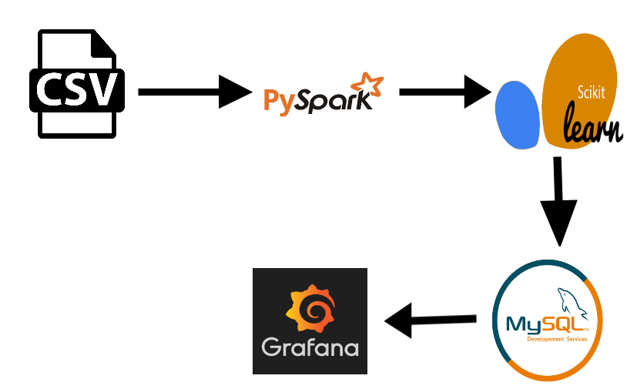

**UML Diagram:**

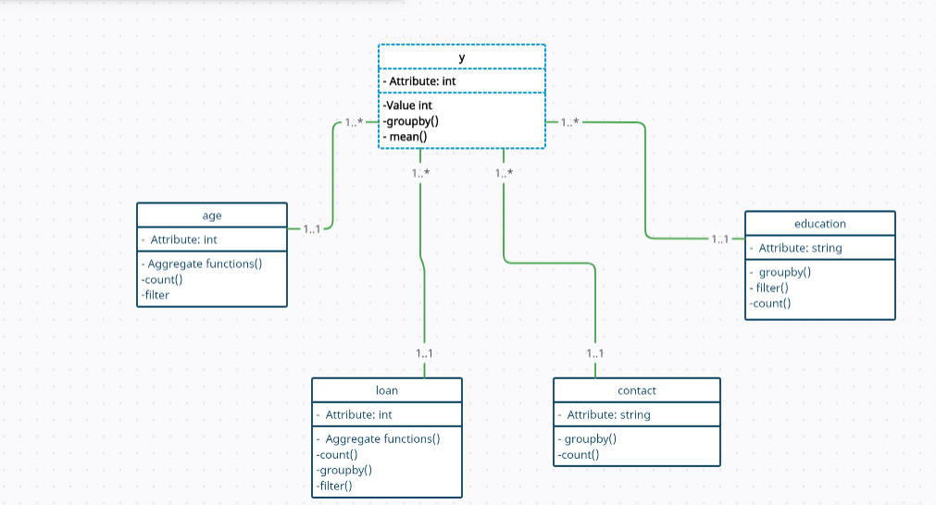

**Use Case Diagram:**

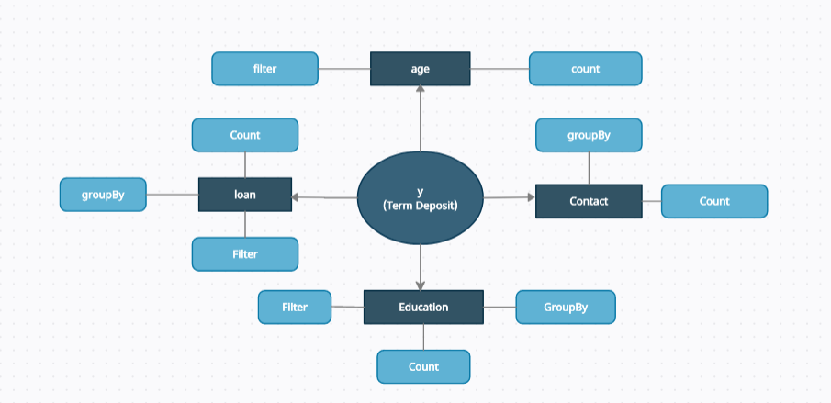

**TEAM B**

Vaishali S

Sathya Narayanan S

Manju R

Monisha K

Pooja Bedi V